Phone: (804) 733-4684
E-mail: sales@central-marketing.com
Web: www.central-marketing.com

Electric Tire Lift

110 volts, 550 pound lift.
Runs smoothly, quickly and quietly.
No leaks, no tangles, no drifting.
Reaches the floor to lift rims into place.
When you release the switch, the handle stays put.
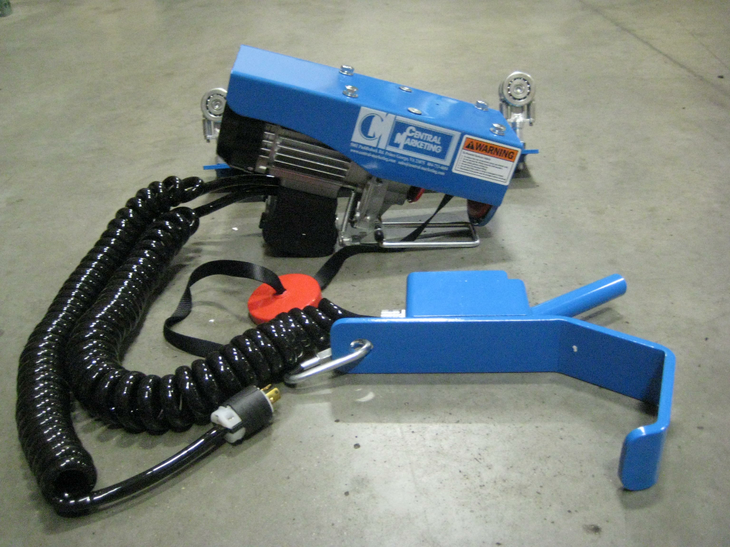

10 foot coiled industrial strength power cord.
10 foot coiled industrial strength control cord that attaches to the handle. Comes with a safety catch between the two trolleys so it will catch itself if a trolley falls out of track or breaks off. This will prevent injury. Ergonomic design on the handle.
Will ride on the same track as the current air lift. Just need to have a 110 volt outlet nearby.

